www.nj.gov/dca | Twitter @NJDCA | Facebook @NJDeptofCommunityAffairs | Instagram @NJ_DCA | Linkedin @
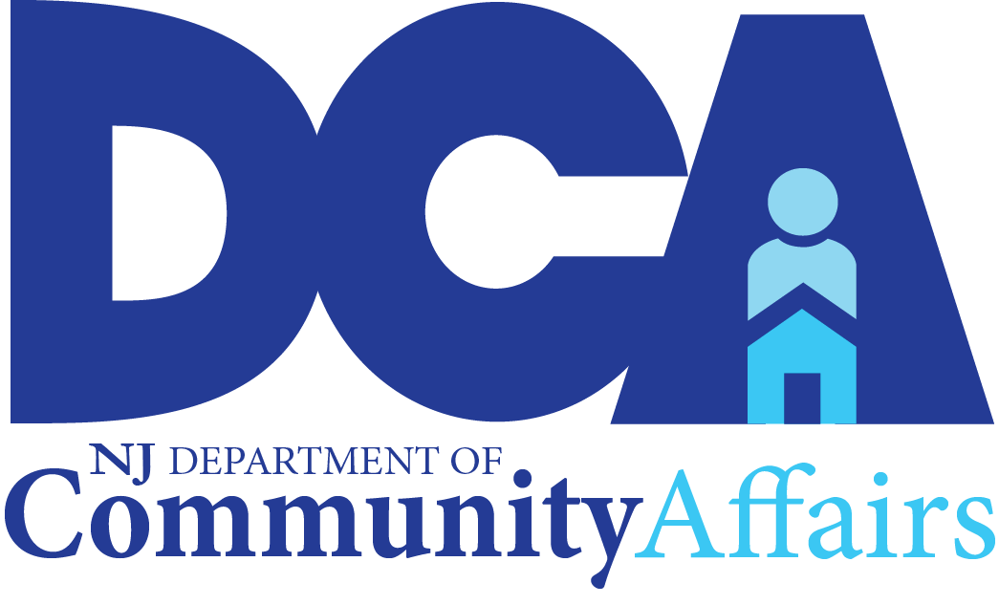
The New Jersey Department of Community Affairs
Social Media Toolkit for the Eviction and Foreclosure Moratorium for Renters and Homeowners
in Response to the COVID-19 Pandemic

SOCIAL MEDIA GRAPHICS AND POST CONTENT WITH SUGGESTED POST SCHEDULE
(all post copy fits within 280 Twitter character limit)
SUGGESTED SCHEDULE | GRAPHIC | POST COPY (ENGLISH)
Day 1 - Morning | renter_1.jpg  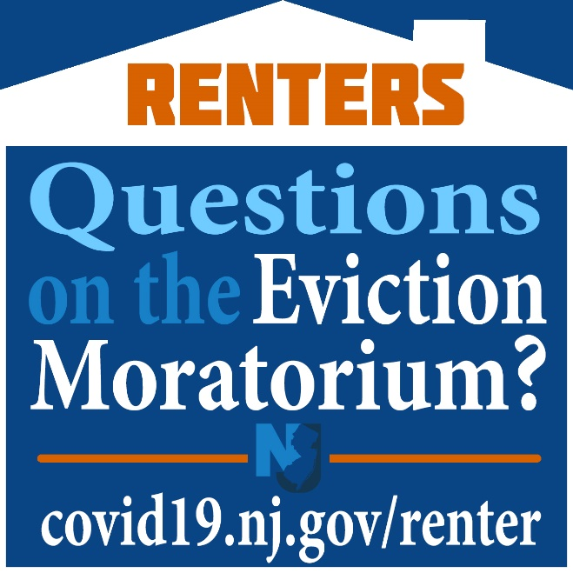 | Attention renters: NO ONE may be removed from their home for inability to pay rent during the COVID-19 emergency. This is called an eviction moratorium.  For more info, visit:  Covid19.nj.gov/renter
Day 1 - Afternoon | homeowner_1.jpg  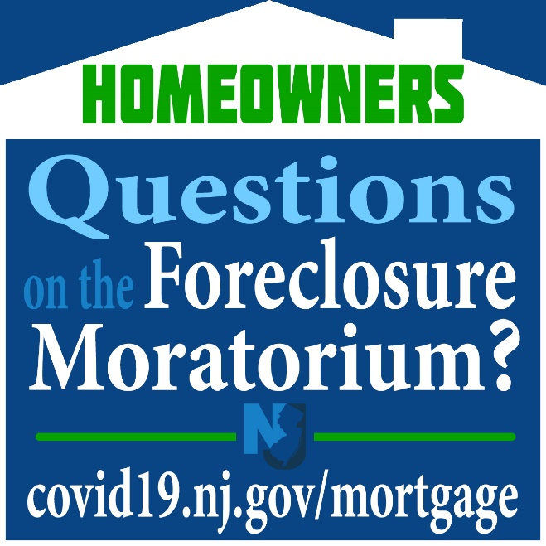 | Attention homeowners: NO ONE may be removed from their home for inability to pay their mortgage during the COVID-19 emergency. This is called a foreclosure eviction moratorium.  For more info, visit:  Covid19.nj.gov/mortgage
Day 2 - Morning | renter_2.jpg  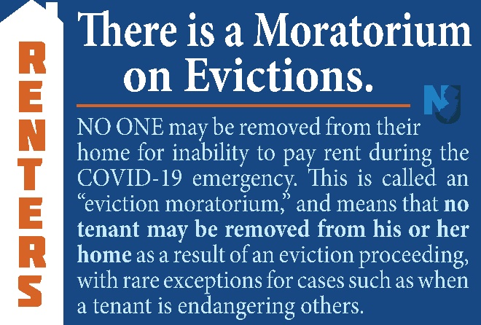 | Attention renters: There is a moratorium on evictions.  NO ONE may be removed from their home for inability to pay rent during the COVID-19 emergency.  For more info, visit:  Covid19.nj.gov/renter
Day 2 - Afternoon | homeowner_2.jpg  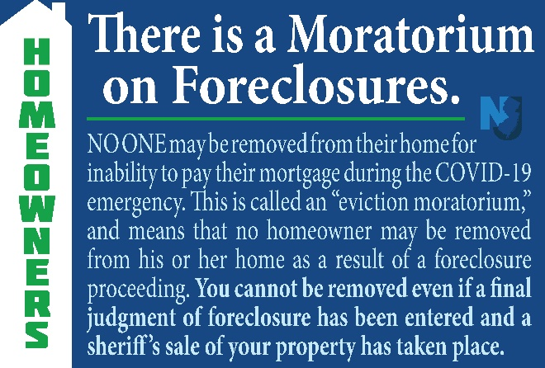 | Attention homeowners: There is a moratorium on foreclosures. NO ONE may be removed from their home for inability to pay their mortgage during the COVID-19 emergency.  For more info, visit:  Covid19.nj.gov/mortgage
Day 3 - Morning | renter_3.jpg  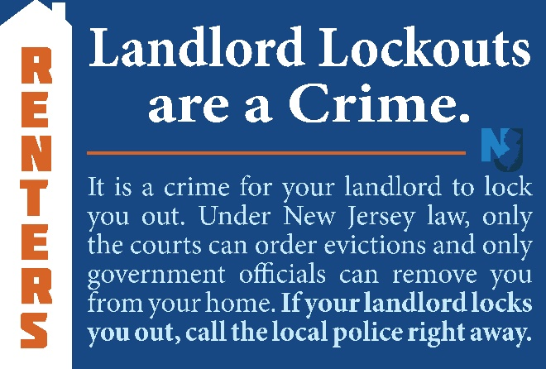 | It's a crime for your landlord to lock you out. Under New Jersey law, only the courts can order evictions and only government officials can remove you from your home. If your landlord locks you out, call the local police right away.  For more info, visit: Covid19.nj.gov/renter
Day 3 - Afternoon | homeowner_3.jpg  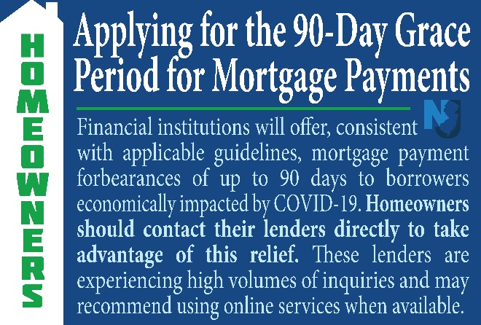 | Financial institutions will offer mortgage payment forbearance of up to 90 days for borrowers economically impacted by COVID-19. Homeowners should contact their lenders directly to take advantage of this relief.  For more info, visit:  Covid19.nj.gov/mortgage
Day 4 - Morning | renter_4.jpg  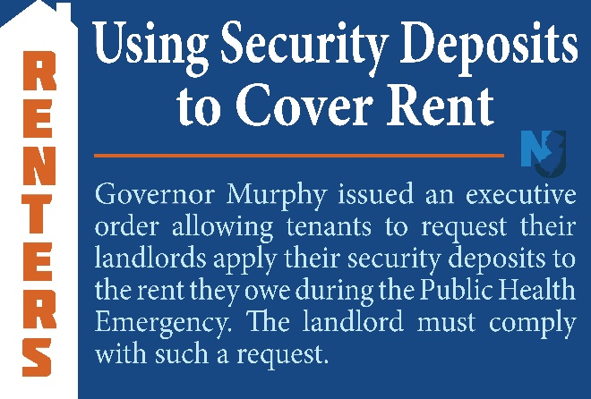 | .@GovMurphy issued an executive order which allows tenants to request in writing that their landlords apply their security deposits to the rent they owe during the Public Health Emergency and for up to 60 days afterwards.  For more info, visit:  Covid19.nj.gov/renter
Day 4 - Afternoon | homeowner_4.jpg  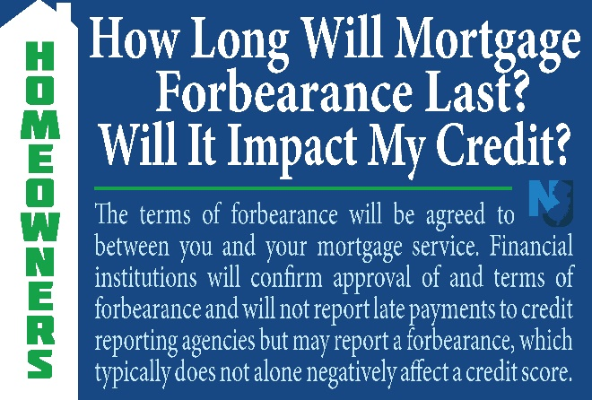 | Mortgage forbearance terms are agreed between you & your mortgage service. Financial institutions won't report late payments to credit reporting agencies but may report a forbearance, which typically doesn't affect a credit score.  For more info, visit: Covid19.nj.gov/mortgage
Day 5 - Morning | renter_5.jpg  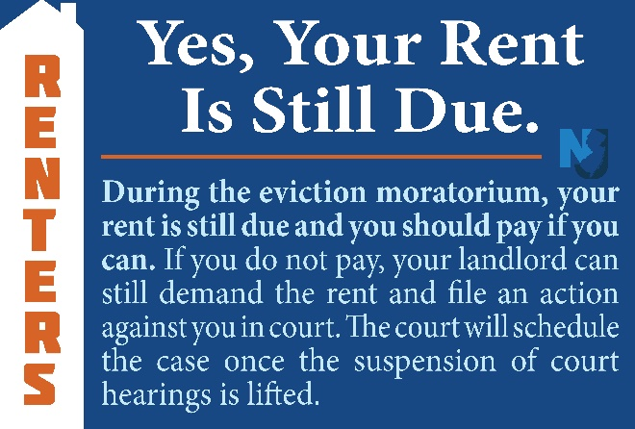 | During the eviction moratorium, your rent is still due and you should pay if you can. For free guidance on how to address your rent situation with your landlord during this time, visit njhousing.gov/foreclosure for a list of counselors by county or call 1-800-NJ-HOUSE.
Day 5 - Afternoon | homeowner_5.jpg  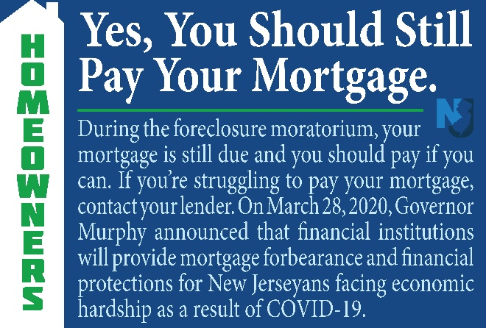 | During the foreclosure moratorium, your mortgage is still due and you should pay if you can. If you’re struggling to pay, contact your lender and they may be able to provide mortgage forbearance.  For more info, visit:  Covid19.nj.gov/mortgage
Day 6 - Morning | renter_6.jpg  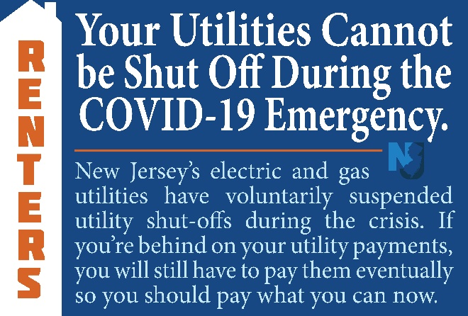 | Electric & gas utilities have suspended shut-offs during the crisis. If you’re behind on payments, you'll still have to pay eventually so pay what you can now. DCA offers assistance with utility bills. To find out if you’re eligible, call 2-1-1 or visit nj.gov/dca/dcaid.
Day 6 - Afternoon | homeowner_6.jpg  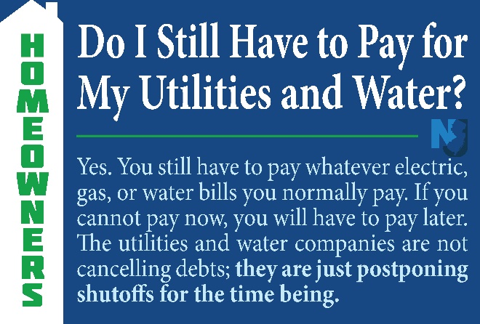 | Electric & gas utilities have suspended shut-offs during the crisis. If you’re behind on payments, you'll still have to pay eventually so pay what you can now. DCA offers assistance with utility bills. To find out if you’re eligible, call 2-1-1 or visit nj.gov/dca/dcaid.
Day 7 - Morning | renter_7.jpg  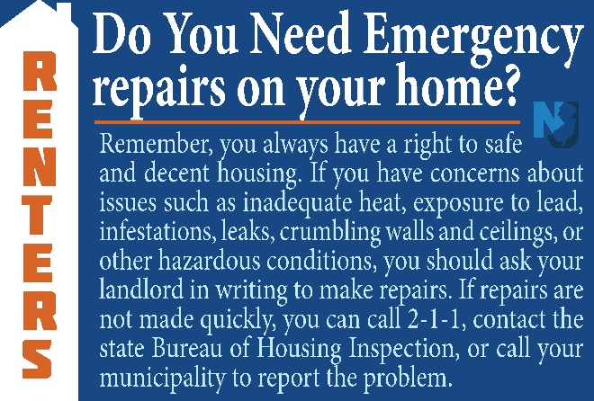 | Remember, you always have a right to safe and decent housing. If you have concerns about issues in your home, you should ask your landlord to make repairs. If repairs are not made quickly, call 2-1-1, contact the state Bureau of Housing Inspection, or call your municipality.
Day 7 - Afternoon | homeowner_7.jpg  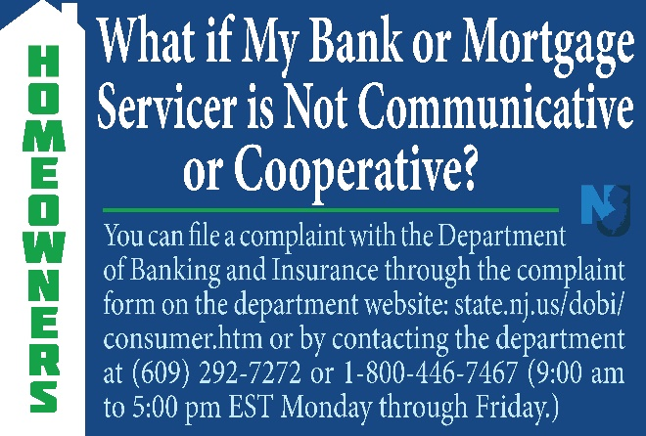 | If you're experiencing issues with your mortgage company, you can file a complaint with @NJDOBI through the complaint form on the department website at state.nj.us/dobi/consumer.htm or by contacting the department Mon through Friday 9am - 5pm at (609) 292-7272 or 1-800-446-7467.
Day 8 - Morning | renter_8.jpg  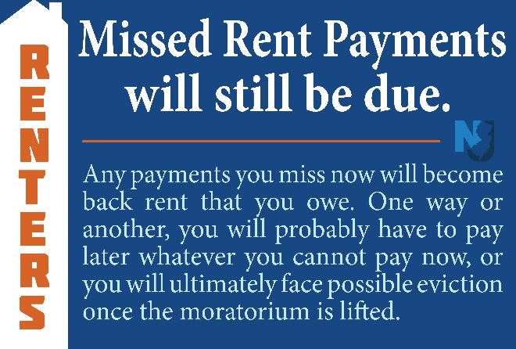 | Any payments you miss now will become back rent that you owe. For free guidance on how to handle your rent situation with your landlord during this time, visit njhousing.gov/foreclosure for a list of counselors by county or call 1-800-NJ-HOUSE.
Day 8 - Afternoon | homeowner_8.jpg  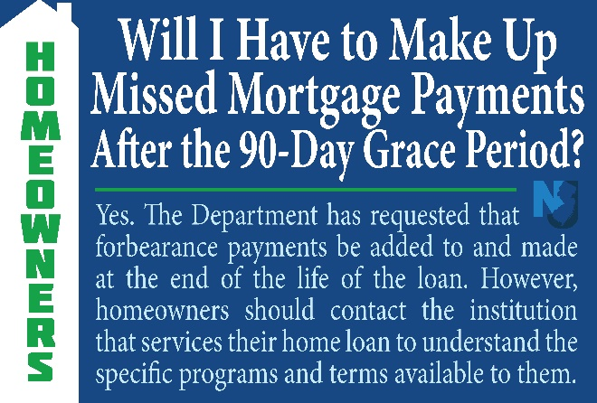 | The state has requested that forbearance payments be added to & made at the end of the life of the loan but homeowners should contact the institution that services their home loan to understand the specific terms available.  For more info, visit: Covid19.nj.gov/mortgage
Day 9 – Morning or Afternoon | homeowner_9.jpg  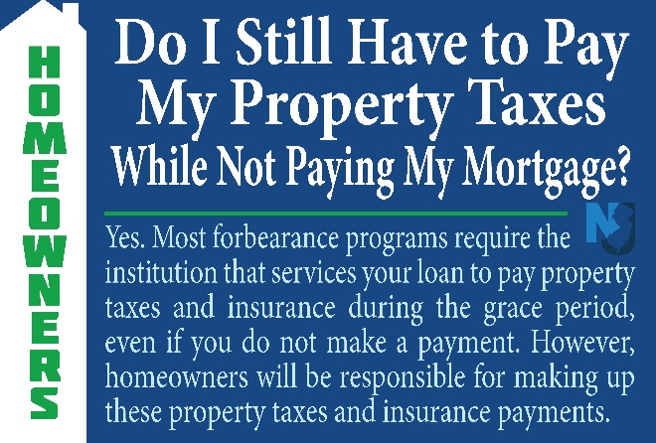 | Most forbearance programs require institutions that service your loan to pay property taxes & insurance during the grace period, even if you don't make a payment. However, homeowners will be responsible for making up those payments.  For more info, visit:  Covid19.nj.gov/mortgage
Day 10 – Morning or Afternoon | homeowner_10.jpg | (1 of 2)  Homeowners should contact the institution that services their home loan to get information about who holds their loan.  For more info, visit:  Covid19.nj.gov/mortgage  (2 of 2)  .@FannieMae and @FreddieMac provide lookup tools for consumers to determine if these entities hold the loan. The tools may be found below:  Fannie Mae - https://www.knowyouroptions.com/loanlookup  Freddie Mac - https://ww3.freddiemac.com/loanlookup/

If you have questions about this social media toolkit, please email: gina.trish@dca.nj.gov

