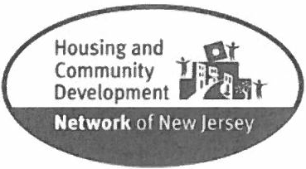

Community Scholar Program

Scholar Application

Due Date: April 4, 2018

Name:
Phone:
Email :
School:

Requested Discipline: Rank your top 3 in order:
_Project Planning
_Construction Management
_Public Policy and Advocacy
_Supportive & Special Needs Housing
_Client Support Programs

_Fund Development
_General Finance
_Project Finance
_Human Resources
_Other:

Current Areas of Study:
Previous Areas of Study:

*Please attach Resume and two (2) Letters of Recommendation (one educational and one professional)

Please provide answers to the following questions:

1. Why do you want to participate in the Community Scholar program? (Minimum 1 page - approximately 500 words. Please be specific.)

- How do you envision this placement through the Community Scholar's program assisting you in your career plan?

- Relevant activities/experiences :

- Computer Proficiency:

Language skills other than English (if applicable):

- Do you need transportation?

- Other pertinent information we need/should (to) know:

I certify that all of the statements in this application are true and complete to the best of my knowledge.
I understand that a false or incomplete answer may be grounds/or not considering me or for my dismissal.

Signature: ____________________________________ Date: _

Please send completed applications to: CommunityScholars@hcdnnj.org
Subject Line: 2018 Community Scholar Application

For questions contact: Terri Benson at 609-393-3752 X 1900 or tbenson@hcdnnj.org

